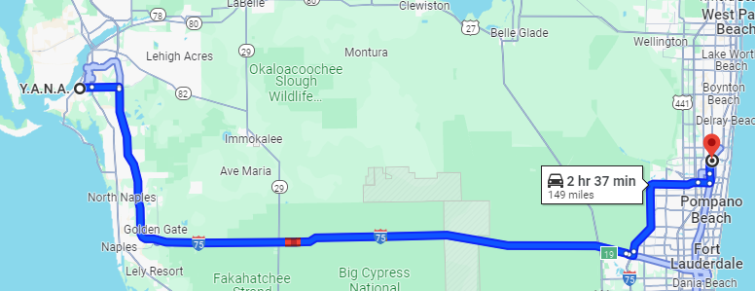

149 miles one way, 298 miles round trip.
Current mileage rate: 67 cents per mile.
Mileage expense requested: $199.66

